THEORY & ALGORITHM OF EACH DAA PRACTICAL

Exp 1: -
Theory –
Insertion sort is a simple sorting algorithm that works by iteratively inserting each element of an unsorted list into its correct position in a sorted portion of the list.
- We start with the second element of the array as the first element is assumed to be sorted.
- Compare the second element with the first element if the second element is smaller than first, then swap them.
- Move to the third element, compare it with the first two elements, and put it in its correct position
- Repeat until the entire array is sorted.
Advantages
- Simple and easy to implement.
- Stable sorting algorithm.
- Efficient for small lists and nearly sorted lists.
- Space-efficient as it is an in-place algorithm.
- Adoptive. the number of inversions is directly proportional to number of swaps. For example, no swapping happens for a sorted array and it takes O(n) time only.
Disadvantages
- Inefficient for large lists.
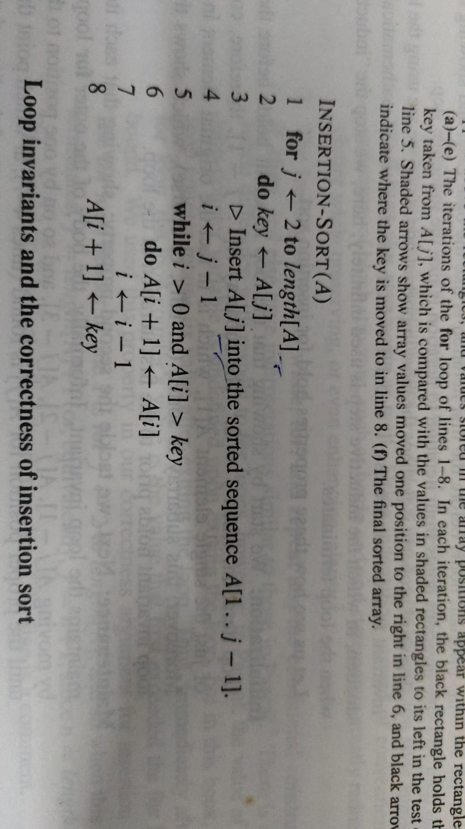
- Not as efficient as other sorting algorithms (e.g., merge sort, quick sort) for most cases.
Algorithm –

Exp 2:
Theory –

- Selection Sort
Selection Sort is a comparison-based sorting algorithm. It sorts an array by repeatedly selecting the smallest (or largest) element from the unsorted portion and swapping it with the first unsorted element. This process continues until the entire array is sorted.
- First we find the smallest element and swap it with the first element. This way we get the smallest element at its correct position.
- Then we find the smallest among remaining elements (or second smallest) and swap it with the second element.
- We keep doing this until we get all elements moved to correct position.
Advantages of Selection Sort
- Easy to understand and implement, making it ideal for learning basic sorting concepts.
- Requires only a constant O(1) extra memory space.
- It requires less number of swaps (or memory writes) compared to many other standard algorithms. Only cycle sort beats it in terms of memory writes. Therefore it can be simple algorithm choice when memory writes are costly.
Disadvantages of the Selection Sort
- Selection sort has a time complexity of O(n^2) makes it slower compared to algorithms like Quick Sort or Merge Sort.
- Does not maintain the relative order of equal elements which means it is not stable.
(algo photo whatsapp)
- Bubble Sort
Bubble Sort is the simplest sorting algorithm that works by repeatedly swapping the adjacent elements if they are in the wrong order. This algorithm is not suitable for large data sets as its average and worst-case time complexity are quite high.
- We sort the array using multiple passes. After the first pass, the maximum element goes to end (its correct position). Same way, after second pass, the second largest element goes to second last position and so on.
- In every pass, we process only those elements that have already not moved to correct position. After k passes, the largest k elements must have been moved to the last k positions.
- In a pass, we consider remaining elements and compare all adjacent and swap if larger element is before a smaller element. If we keep doing this, we get the largest (among the remaining elements) at its correct position.
Advantages of Bubble Sort:
- Bubble sort is easy to understand and implement.
- It does not require any additional memory space.
- It is a stable sorting algorithm, meaning that elements with the same key value maintain their relative order in the sorted output.
Disadvantages of Bubble Sort:
- Bubble sort has a time complexity of O(n^2) which makes it very slow for large data sets.
- Bubble sort has almost no or limited real world applications. It is mostly used in academics to teach different ways of sorting.
(algo photo whatsapp)
Exp 3:
Theory –
Searching algorithms are fundamental procedures in computer science used to locate specific data elements within a collection, such as arrays, lists, or databases. These algorithms play a crucial role in optimizing data retrieval, which is essential for efficient program execution and system performance. The two most basic and widely studied searching techniques are linear search and binary search.
Linear search is a straightforward method that sequentially examines each element in the list until the target element is found or the list ends. Although simple to implement, linear search is inefficient for large datasets, offering a worst-case time complexity of O(n).
Binary search, on the other hand, is a significantly more efficient algorithm but requires the input data to be sorted. It operates by repeatedly dividing the search interval in half, comparing the target value to the middle element of the array. If a match is not found, the search continues in the appropriate half. Binary search has a time complexity of O(log n), making it highly suitable for large, sorted datasets.
(Algorithms for both of them in notebook)
Exp 4:
Theory –
Merge Sort is a popular divide and conquer algorithm used for sorting. In this algorithm, the input array is recursively divided into two halves until each sub-array contains only a single element. Then, the sub-arrays are merged in a sorted manner to produce the final sorted array. The key operation in Merge Sort is the merging step, which combines two sorted arrays into one sorted array efficiently. This algorithm is stable and has a time complexity of O(n log n) in all cases—best, average, and worst. It is particularly useful for sorting linked lists and large datasets where stability is important. During our DSA lab experiment, we implemented merge sort using recursion and observed how the array was split and merged step-by-step. The experiment demonstrated the algorithm’s consistent performance regardless of the initial order of elements, making Merge Sort a reliable sorting technique.
(algorithm in notebook)
Exp 5:
Theory –
Quick Sort is an efficient divide and conquer sorting algorithm. It works by selecting a pivot element from the array and partitioning the other elements into two sub-arrays—those less than the pivot and those greater than the pivot. These sub-arrays are then recursively sorted. The performance of Quick Sort heavily depends on the choice of pivot; in the best and average cases, it offers O(n log n) time complexity, but in the worst case (e.g., when the smallest or largest element is always chosen as pivot), it degrades to O(n²). Despite this, it is often faster in practice than other algorithms like Merge Sort due to its in-place sorting and low memory usage. In our DSA lab experiment, we implemented Quick Sort using recursion and analysed how the partitioning process works. The experiment helped us understand the role of pivot selection in optimizing the algorithm's performance.
(algorithm in notebook)
Exp 6:
Theory –
The Fractional Knapsack Problem involves selecting items with given weights and values to maximize the total value within a fixed knapsack capacity. Unlike the 0/1 Knapsack Problem where items must be taken whole, fractional knapsack allows taking any fraction of an item. The greedy algorithm solves this problem optimally by first calculating the value-to-weight ratio for each item and sorting the items in descending order based on this ratio. It then iteratively adds as much of the highest ratio item as possible to the knapsack until the capacity is exhausted. This method guarantees the maximum possible value, leveraging the problem’s optimal substructure and greedy-choice properties for an efficient and effective solution.
(algorithm in notebook)
Exp 7:
Theory –
This program demonstrates Prim’s Algorithm, a greedy method used to find the Minimum Spanning Tree (MST) of a connected, weighted, undirected graph. The MST connects all vertices with the minimum possible total edge weight, ensuring no cycles. The graph is represented as an adjacency list, where each node stores its connected edges and associated costs.
The program first generates a random connected graph using the createGraph function, which guarantees connectivity by initially linking each vertex to a previous one, then adds extra edges to increase graph density. Edge weights are randomly assigned.
Prim’s algorithm starts from an arbitrary vertex and grows the MST by repeatedly adding the smallest edge that connects a new vertex. A priority queue efficiently selects these edges, while arrays track visited vertices and minimum edge costs.
The program runs Prim’s algorithm on graphs of increasing sizes, measuring execution time to demonstrate how the algorithm performs on larger datasets. This highlights both the algorithm’s correctness and efficiency.
(algorithm in notebook)
Exp 8:
Theory –
Kruskal’s algorithm is a classical greedy approach to finding the Minimum Spanning Tree (MST) of a connected, weighted, undirected graph. The algorithm begins by sorting all the edges in non-decreasing order based on their weights. It then processes each edge in this order, adding it to the MST if it connects two previously unconnected components, thereby avoiding cycles. To efficiently check and manage the connected components, Kruskal’s algorithm utilizes a Disjoint Set Union (DSU) or Union-Find data structure, which supports quick union and find operations. By repeatedly selecting the smallest available edge that maintains the acyclic property, the algorithm constructs an MST with the minimum total edge weight. Kruskal’s algorithm performs particularly well on sparse graphs and is widely applied in network design, clustering, and other optimization problems involving minimal connectivity costs.
(algorithm in notebook)
Exp 9:
Theory –
This implementation showcases Dijkstra’s algorithm to compute the shortest paths from a designated source vertex to all other vertices within a weighted, undirected graph. The graph is constructed as an adjacency list, initially ensuring connectivity by forming a spanning tree, then augmenting it with additional randomly weighted edges to reach a specified edge count. Dijkstra’s algorithm employs a priority queue to efficiently select the vertex with the minimum tentative distance, iteratively relaxing the edges to update the shortest path estimates. This method guarantees the determination of the minimum distance paths in graphs with non-negative edge weights. The program also benchmarks the algorithm’s execution time across varying graph sizes, demonstrating its scalability and efficiency, especially on large sparse graphs. Such an approach is critical in applications involving network routing, geographic navigation, and various optimization problems.
(algorithm in notebook)
Exp 10:
Theory –
The Floyd–Warshall algorithm is a dynamic programming technique used to find the shortest paths between all pairs of vertices in a weighted graph. It efficiently handles both directed and undirected graphs and can detect negative edge weights (but not negative cycles). The algorithm works by iteratively improving the estimated shortest paths through an intermediate vertex set. For each pair of vertices (i, j), it checks whether including a vertex k as an intermediate point provides a shorter path. The time complexity is O(V³), where V is the number of vertices, making it suitable for dense graphs or graphs with a small number of vertices.
(algorithm in notebook)
Exp 11:
Theory –
The N-Queens problem is a classic example of using the backtracking algorithm to find all possible arrangements of N queens on an N×N chessboard such that no two queens attack each other. A queen can move any number of squares vertically, horizontally, or diagonally. The backtracking approach incrementally places queens one by one in different columns, checking for conflicts at each step. If a valid position is found, it proceeds to place the next queen; otherwise, it backtracks and tries another position. This systematic search continues until all solutions are found. The algorithm’s time complexity is approximately O(N!).
(algorithm in notebook)

